Interview Questions HFT Firms ACTUALLY Ask (India)

These are real patterns, not LeetCode fluff.

🔥 Java & JVM (Most Asked)
- How does GC affect latency? Which GC would you choose and why?
- Explain false sharing. How do you avoid it?
- Difference between volatile, Atomic, and synchronized?
- What happens during JIT compilation?
- How would you design a zero-allocation system?

🔥 Concurrency & Performance
- Design a lock-free queue
- Why is busy-spin used in HFT?
- What is cache line size and why does it matter?
- Explain memory visibility in Java

🔥 Systems & Networking
- TCP vs UDP — when would you use each?
- How do exchanges send market data?
- What causes jitter? How do you reduce it?
- What is NUMA and why should we care?

🔥 Trading-Aware Questions (Light Finance)
- What is an order book?
- Difference between limit and market order?
- Where would you put risk checks in the pipeline?

🔥 Design Question (Almost Guaranteed)
“Design a low-latency trading system.”
They expect:
- Clear pipeline
- Latency-critical vs non-critical separation
- Threading model
- Failure handling

3️⃣ HFT-Style Java Project for Your CV (VERY IMPORTANT)
This project separates serious candidates from everyone else.

🎯 Project Title
Low-Latency Java Trading Engine (HFT-Style)

🧠 Architecture
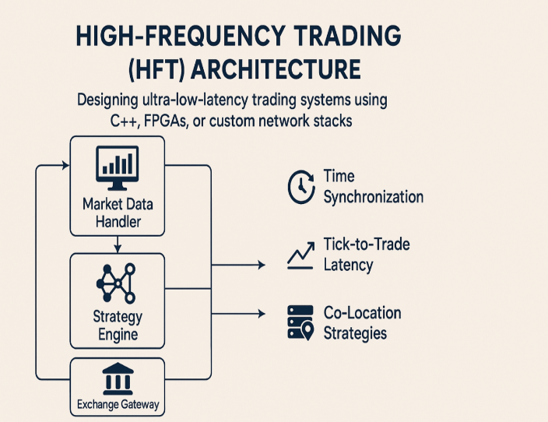 | 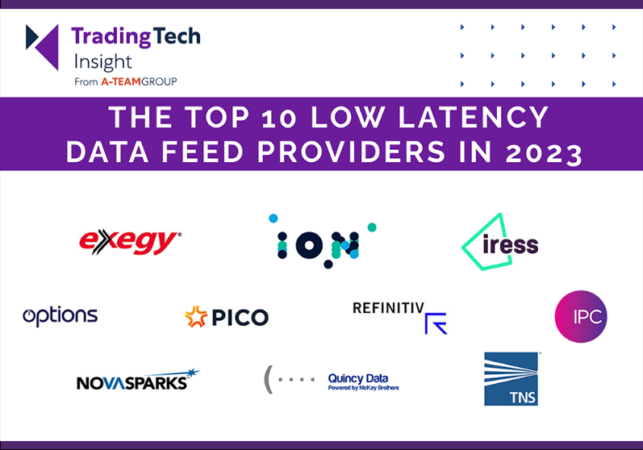

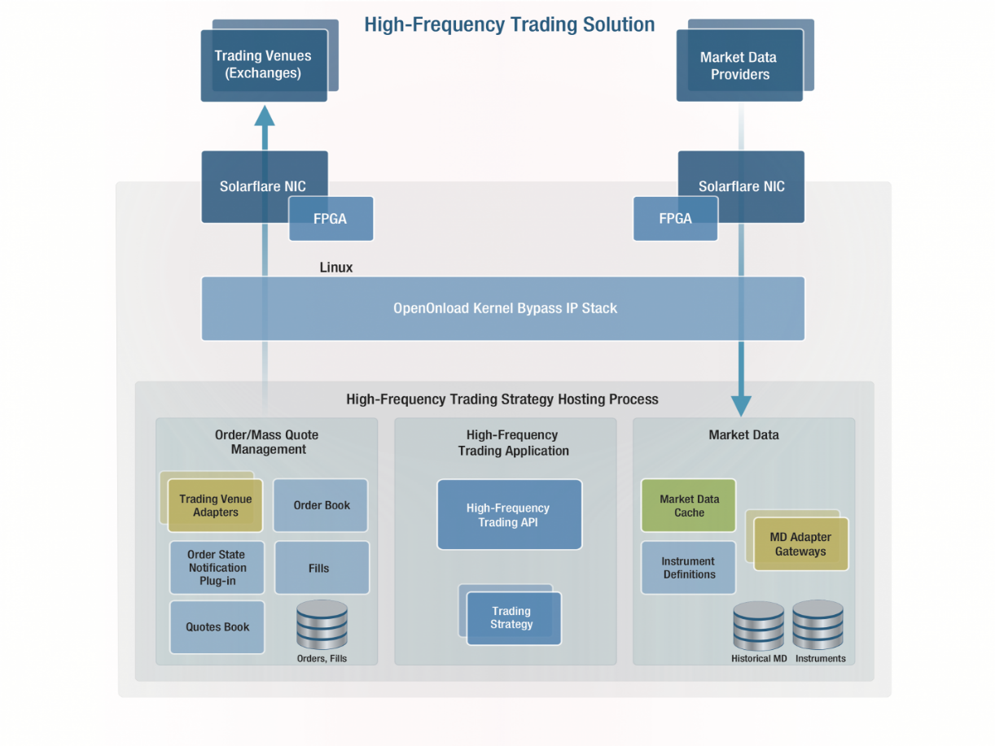
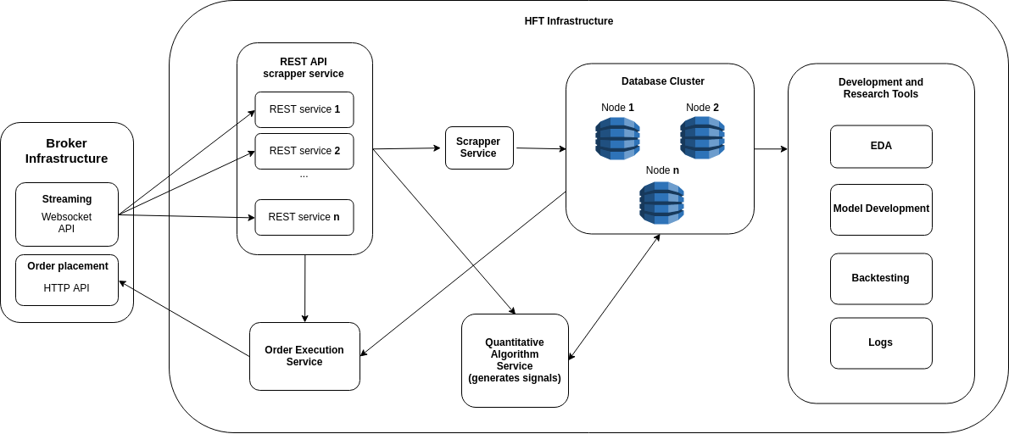
Components
- Market Data Feed Handler (UDP)
- In-Memory Order Book
- Strategy Engine
- Risk Checks
- Order Gateway (FIX-like simulation)

⚙️ Technical Requirements (What Interviewers LOVE)
Java
- No object allocation in hot path
- Ring buffer between components
- Single-writer principle
- Busy-spin threads
Performance
- Measure p99 latency
- Show before/after tuning
- CPU pinning enabled

📂 Repo Structure
hft-java-engine/
├── marketdata/
├── orderbook/
├── strategy/
├── risk/
├── gateway/
├── benchmark/
└── README.md

📝 README MUST Explain
- Why each design decision was made
- Where latency matters
- Trade-offs (correctness vs speed)
- Benchmarks

💼 How to Put This on Your CV
Low-Latency Java Trading Engine
- Built zero-GC, lock-free market data → order execution pipeline
- Achieved p99 latency under X µs
- Implemented UDP feed handler, in-memory order book, risk checks
This alone can double your interview calls.

